## **Software Engineering Process**

**SOEN 6011**

Summer 2016

**Assignment 3**

Group 6

**Prepared by:**

Vivek Khatri 27292848

Navneet Kaur 27676638

SarvenazKhaksarfard 40002880

Pardeep Kaur 40014804

Muhammad Raza Khan 27735987

Neha Kumari 27382073

Ankit Lathia 27378327

MiteshKaura 27284756

# Domain Model:

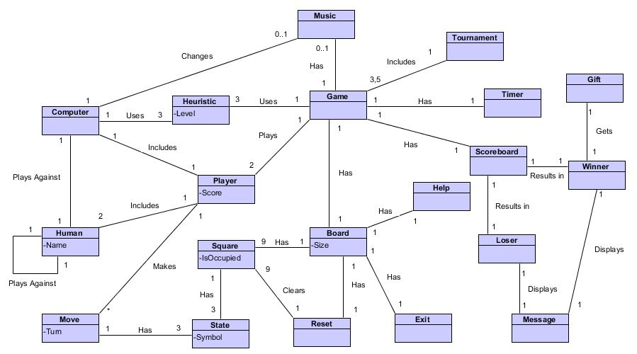

This domain model illustrates the noteworthy concepts that would be used in the game of Tic Tac Toe, without entering too much into the technical details. The purpose of this domain model is to give an insight into the working of the product we intend to develop, in laymen terms.

The main conceptual class which other classes revolve around is the Game (Tic Tac Toe).

The Game is played by Player which could be a Human or a computer. In case the players are Human,the players can play against each other. However, if a Human player is playing against the Computer, the computer uses Heuristics to play at different levels against the human players.

Each Player has a set of moves that he/she can make against each other. The Game primarily consists of a Board which is made up of Squares. A Square can consist of State symbols which could be X, O or blank. The Reset can change the State of Squares to empty and not occupied.

The Game also has the feature of Music and Timer. The game changes its music if it is playing against the computer. The Game can also be played as a Tournament, which could be played as best out of 3 or5 games in determining the winner.

Furthermore, The Game has a Scoreboard (only for maintaining scores), which acts as a determinant in deciding the winner or loser of the game. Both, the winner and loser are then displayed as a message, indicating their win or loss. The Winner of the game gets a Gift.

Some important attributes for Conceptual Classes are:

1) A human player can have a designated name.

2) The Heuristics represents different levels for CPU.

3) A player can check his score.

4) The moves made by players depend on the turn of players.

5) A state of square could only be ‘X’, ‘O’ or empty.

6) After a user clicks the square, the state of that particular square can only be ‘X’ or ‘O’.

Some of the important Cardinalities are:

1) A game can be played by only 2 players and not more than that.

2) A board contains of only 9 squares, no more or less.

3) The reset button empties all the 9 squares, no matter what the current state is.

4) A tournament can have either 3 or 5 games.

5) The game has 3 different heuristics. (Easy, medium and Hard).

6) A square has 3 states, which could be ‘X’, ‘O’ or ‘empty’.